**Configure static IP addresses, modify MAC addresses, and verify network connectivity using ping and ifconfig commands.**

**Manual IP:**

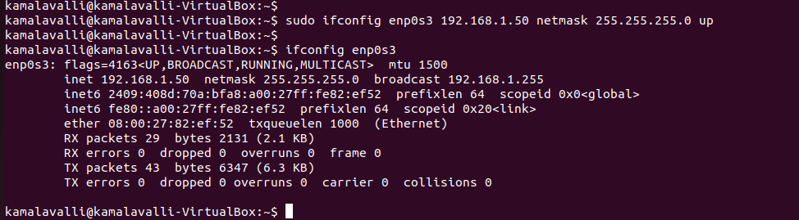

**Modifying MAC:**

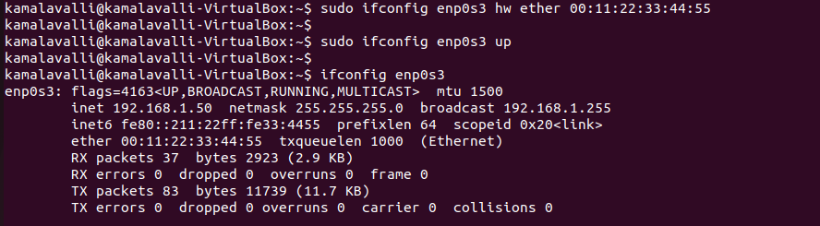

**Pinging Router Gateway:**

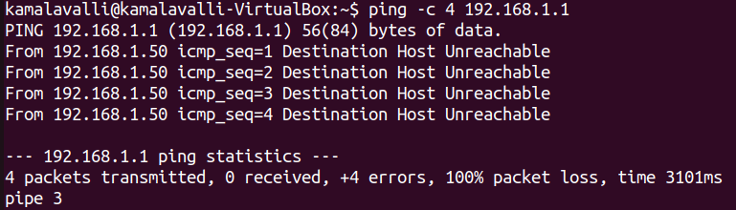

**Pinging Google:**

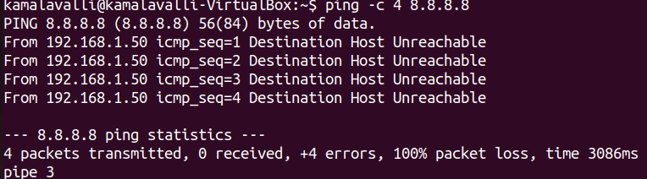

**Observation:**

* After modifying the IP address and MAC address of enp0s3, I can ping my own IP (192.168.1.50), which confirms that the changes were applied. But when I try to ping the default gateway (192.168.1.1), I get a "Destination Host Unreachable" error. Pinging 8.8.8.8 also does not work, meaning there is no internet connectivity.
* Ping to the default gateway (192.168.1.1) fails because after changing the MAC address, the router might not recognize my system, or my system has not learned the correct MAC address of the gateway. The routing table might also be missing or incorrect.
* Ping to 8.8.8.8 fails because the default gateway is unreachable. Since my system cannot communicate with the router, it cannot send packets to external networks, resulting in no internet access.